**Name -** Prayas Prakash Sambhare

**Roll no –** 17ME33039

**Directions to run the code**

**1) Installing necessary libraries and python dependencies**

To run the file one must have python 3 installed in their machines. You can download python from here. (<https://www.python.org/downloads/>)

The code is based on numpy, sympy, matplotlib, and tkinter libraries in python. These libraries are necessary to run the code.

Install numpy :- <https://pypi.org/project/numpy/>

Install sympy :- <https://pypi.org/project/sympy/>

Install matplotlib :- <https://pypi.org/project/matplotlib/>

Install tkinter :- <https://www.javatpoint.com/how-to-install-tkinter-in-python>

If one wants to avoid all the above installations, then simply install anaconda (<https://docs.anaconda.com/anaconda/install/windows/> ) which comes with the above libraries pre-installed.

**2) Running the program**

Download the file. Now open the command prompt and change the directory where the files are downloaded.

Run the following command in the command prompt or anaconda prompt.

python CLT_project.py

A new window of Gui will open as following:

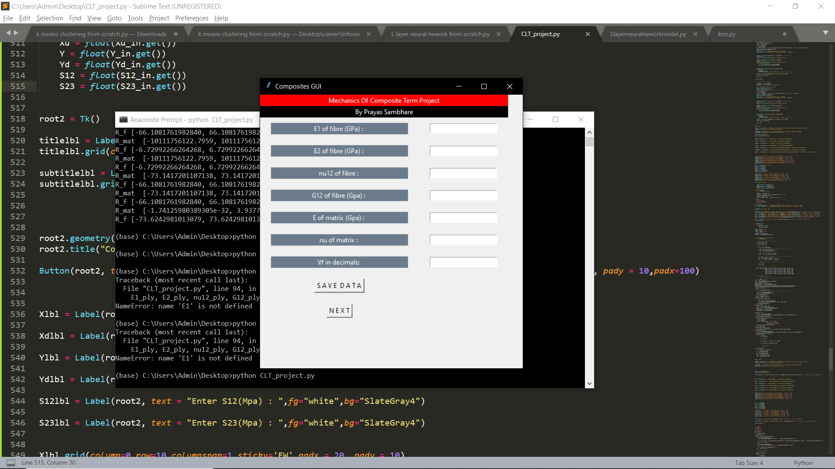

Enter the properties and click on SAVE DATA to save your entered values and click on NEXT.

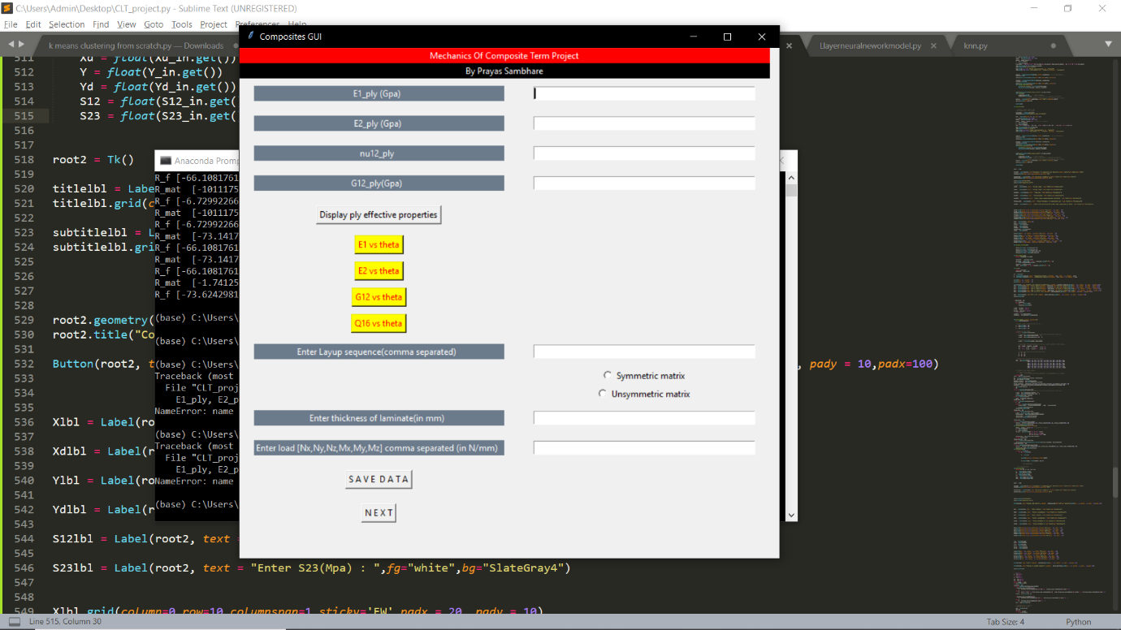Click on display ply effective properties to view the effective properties.

To view plot you can click on any of the yellow button.

Enter the layup sequence, thickness and load. Save the data and click on next

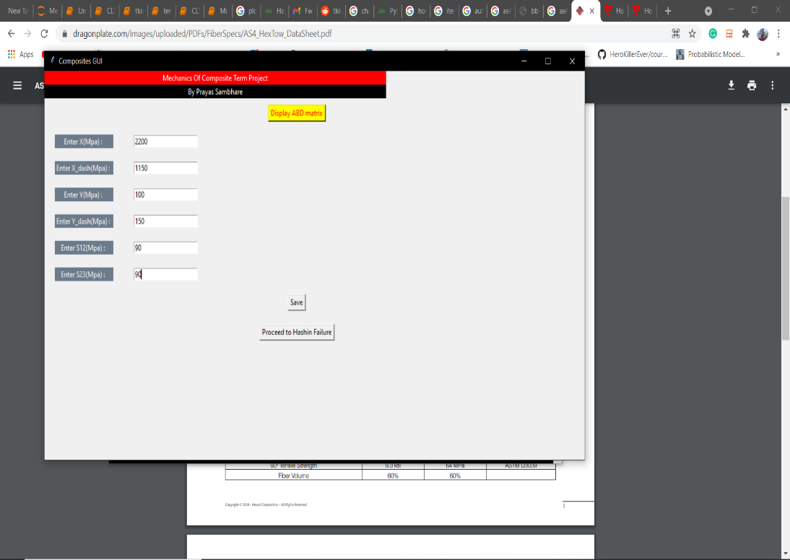Enter the values of asked values and save

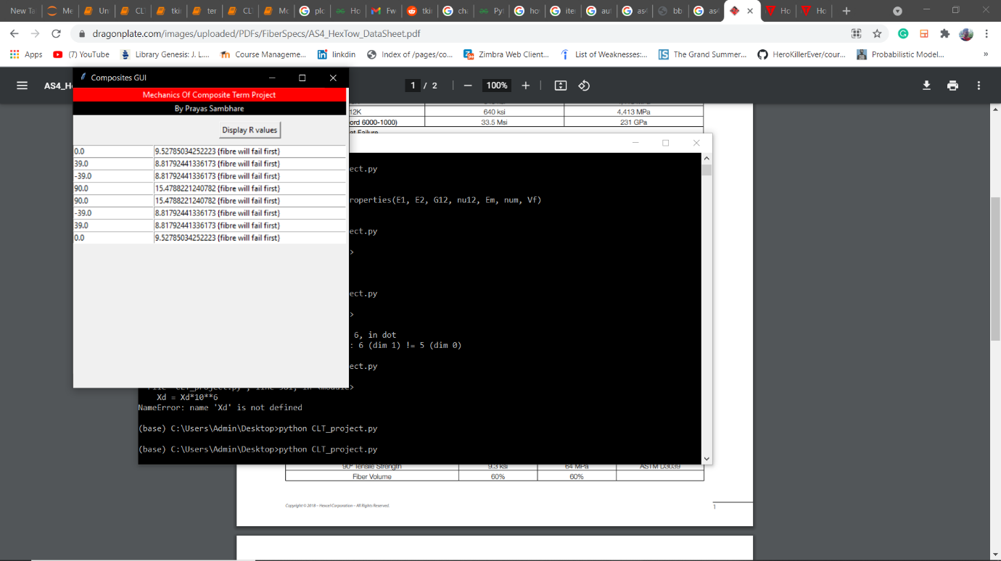Click on Display R values to get the R.